REPORT

ON

BANK MARKETING

**TEAM NAME:**

QUEST PIRATES

**TEAM MEMBERS:**

P.SRUJANA

P.ALEKHYA

P.V.RAKESH

S.SAI SARVANI

P.TANUJA DEVI

TABLE OF CONTENTS

1. Title of the project
   1. Introduction
   2. Objectives of research
   3. Problem Statement
   4. Industry Profile
2. Review of literature
3. Data Collection
4. Methodology
   1. Exploratory Data Analysis

4.1.1 Figures and tables

* 1. Statistical Techniques and Data Visualization
  2. Data Modeling using Supervised ML techniques

1. Findings and Suggestion
2. Conclusion
3. References

BANK MARKETING

# 1.1 INTRODUCTION

Bank market campaigns today mostly rely on human expert’s opinions on choosing potential customers. This method is time consuming and lacks accuracy. As banks have very structured and detailed client information and transaction records, it is desirable to build data driven decision making systems with guaranteed high successful rate at campaigns. Machine Learning models and techniques have huge potential to show their power in such problem settings. This project report shows how machine learning algorithms can be applied in such practical problem settings, especially with big data sets. The report discusses the case studies regarding machine learning models in bank marketing in details. The report also addresses some practical annoying problems existing in different training algorithms. Some simple but useful solutions are provided and discussed. This work can serve as a reference to future bank marketing campaign system modeling and other data driven decision making systems designs.

# 1.2 OBJECTIVES OF RESEARCH

The main objective of this project is to increase the effectiveness of the bank marketing. This project will enable the bank to develop a more granular understanding of its customer base, predict customers' response to its telemarketing campaign and establish a target customer profile for future marketing plans.

By analyzing customer features, such as demographics and transaction history, the bank will be able to predict customer saving behaviors and identify which type of customers is more likely to make term deposits. The bank can then focus its marketing efforts on those customers. This will not only allow the bank to secure deposits more effectively but also increase customer satisfaction by reducing undesirable advertisements for certain customers.

# 1.3 PROBLEM STATEMENT

This project utilizes different types of Machine Learning algorithms, using the Bank

Marketing dataset, to check if the client has subscribed for a term deposit depending on various bank marketing attributes like age, type of job, education level, if the client has a housing loan or not, last date of contact, etc.

Logistic Regression has been chosen as the benchmark model for this project and will be compared to the following classifiers:

* Random Forest Classifier
* Gaussian Naïve Bayes Classifier
* KNN
* Support Vector Machine

Finally, from all the above-mentioned classifiers with the benchmark classifier (Logistic Regression classifier).

# 1.4 INDUSTRY PROFILE

FICO (Fair Isaac Corporation) as a system had (and has) its strengths, but there were weaknesses, too.

Applicants who lacked credit history couldn’t prove their ability to pay, although those without credit history could be working toward a future that would certainly support paying back loans.

Because of reasons like this, a new form of credit checking, banking, loans and mortgages needed to be developed, and that’s where machine learning begin to enter the scene — as detailed in a recent Financial Stability Board summary. From my observation, a lot of new fin tech firms or bank tech firms have erupted in recent times to target newer groups of consumers who prefer to do things virtually. Some banks have also developed solutions to target thin-file customers. For example, technology can help monitor various alternative sources of information on creditworthiness, like ensuring they are paying rent and utilities on time.

This might seem like a complicated concept, but there are several machine learning factors that can benefit the lending industry.

Following are some of the potential benefits machine learning and AI could provide.

* Manage Portfolios With Algorithms
* Conduct High-Frequency Trading
* Detect Frauds And Threats to Financial Systems
* Lend Credit To The Underserved
* Personalize Customer Service In A Digital World

# 2 REVIEW OF LITERATURE

* Literature review analyses research on bank marketing.
* Analysis indicates the customer’s interest for crediting a deposit.
* Assessing which ML classification technique to use is an important step that needs to be done.

# 3 DATA COLLECTION

The data collection consists of

* **Data Set Information**
* **Attribute Information**

**Data Set Information**

The data is related to bank marketing. The marketing campaigns were based on phone calls. Often, more than one contact to the same client was required, in order to access if the product (bank term deposit) would be ('yes') or not ('no') subscribed.

The dataset is Bank-additional-full.csv with all examples (41188) and 21 inputs.

The classification goal is to predict if the client will subscribe (yes/no) a term deposit (variable y).

**Attribute Information:**

### **Bank client data:**

* Age (numeric)
* Job : type of job (categorical: 'admin.', 'blue-collar', 'entrepreneur', 'housemaid', 'management', 'retired', 'self-employed', 'services', 'student', 'technician', 'unemployed', 'unknown')
* Marital : marital status (categorical: 'divorced', 'married', 'single', 'unknown' ; note: 'divorced' means divorced or widowed)
* Education (categorical: 'basic.4y', 'basic.6y', 'basic.9y', 'high.school', 'illiterate', 'professional.course', 'university.degree', 'unknown')
* Default: has credit in default? (categorical: 'no', 'yes', 'unknown')
* Housing: has housing loan? (categorical: 'no', 'yes', 'unknown')
* Loan: has personal loan? (categorical: 'no', 'yes', 'unknown')

### **Related with the last contact of the current campaign:**

* Contact: contact communication type (categorical: 'cellular','telephone')
* Month: last contact month of year (categorical: 'jan', 'feb', 'mar', ..., 'nov', 'dec')
* Day_of_week: last contact day of the week (categorical: 'mon','tue','wed','thu','fri')
* Duration: last contact duration, in seconds (numeric). Important note: this attribute highly affects the output target (e.g., if duration=0 then y='no'). Yet, the duration is not known before a call is performed. Also, after the end of the call y is obviously known. Thus, this input should only be included for benchmark purposes and should be discarded if the intention is to have a realistic predictive model.

### **Other attributes:**

* Campaign: number of contacts performed during this campaign and for this client (numeric, includes last contact)
* Pdays: number of days that passed by after the client was last contacted from a previous campaign (numeric; 999 means client was not previously contacted)
* Previous: number of contacts performed before this campaign and for this client (numeric)
* Poutcome: outcome of the previous marketing campaign (categorical: 'failure','nonexistent','success')

### **Social and economic context attributes**

* Emp_va__rate: employment variation rate - quarterly indicator (numeric)
* Cons_price_idx: consumer price index - monthly indicator (numeric)
* Cons_conf_idx: consumer confidence index - monthly indicator (numeric)
* Euribor3m: euribor 3 month rate - daily indicator (numeric)
* Nr_employed: number of employees - quarterly indicator (numeric)

### **Output variable (desired target):**

* y - Has the client subscribed a term deposit? (binary: 'yes', 'no')

Out of the 21 attributes in the dataset some of the attributes are dropped from the dataset as they are independent of the target attribute.

The dropped attributes are pdays ,default, contact, day_of_week, month.

# 4 Methodology

Methodology consists of

* Exploratory Data Analysis
* Figures and tables
* Statistical Techniques and Data Visualization
* Data Modeling using Supervised ML techniques

# 4.1 EXPLORATORY DATA ANALYSIS

To obtain a better understanding of the dataset, the distribution of key variables and the relationships among them were plotted.

# 4.1.1 FIGURES AND TABLES

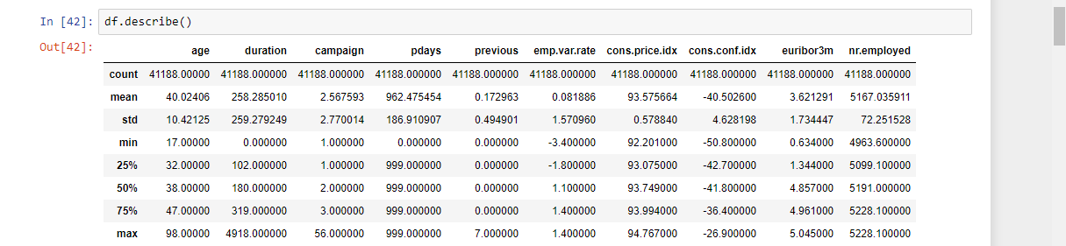

Pandas **describe()** is used to view some basic statistical details like percentile, mean, std etc. of a data frame or a series of numeric values. When this method is applied to a series of string, it returns a different output

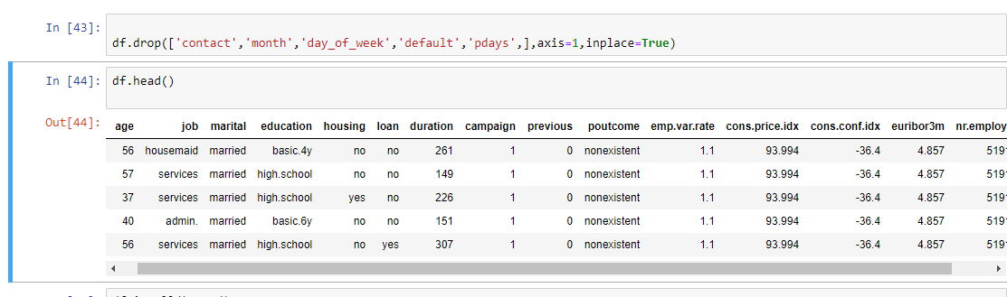

Pandas provide data analysts a way to delete and filter data frame using **drop()**method. Rows or columns can be removed using index label or column name using this method.

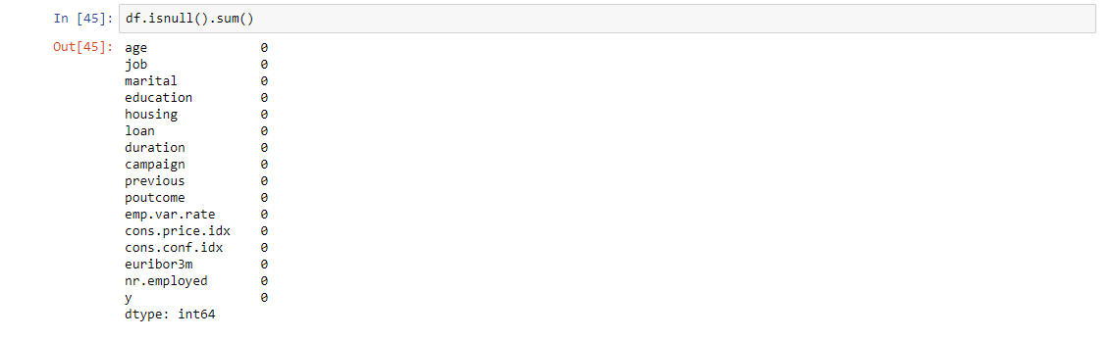

While making a Data Frame from a csv file, many blank columns are imported as null value into the Data Frame which later creates problems while operating that data frame. Pandas isnull() and notnull() methods are used to check and manage NULL values in a data frame. Pandas**dataframe.sum()** function return the sum of the values for the requested axis.

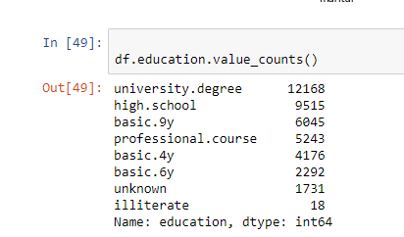

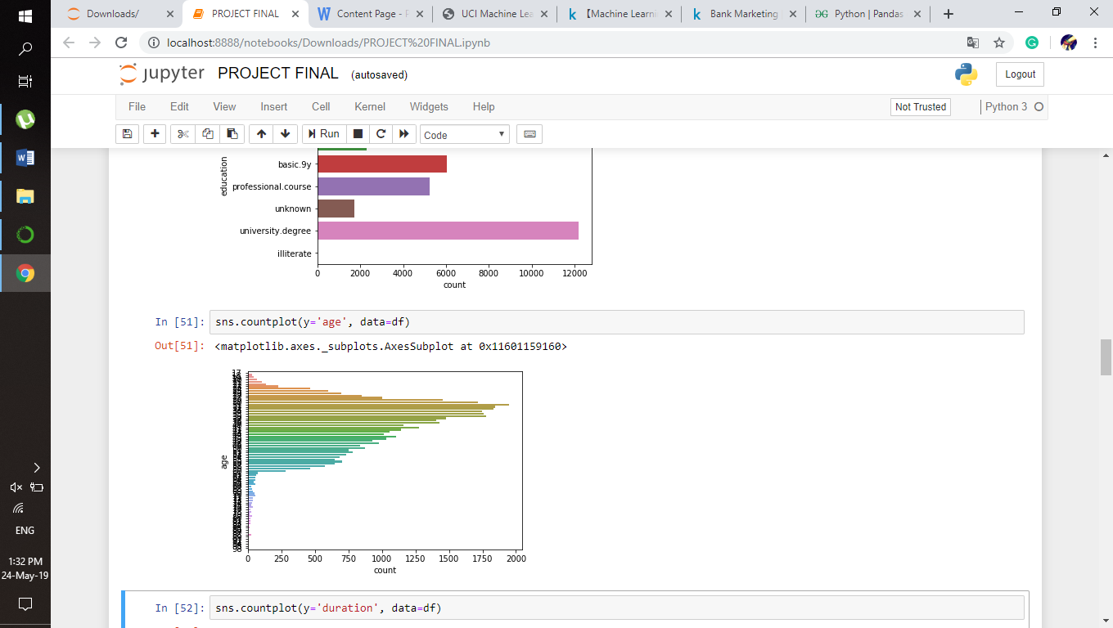

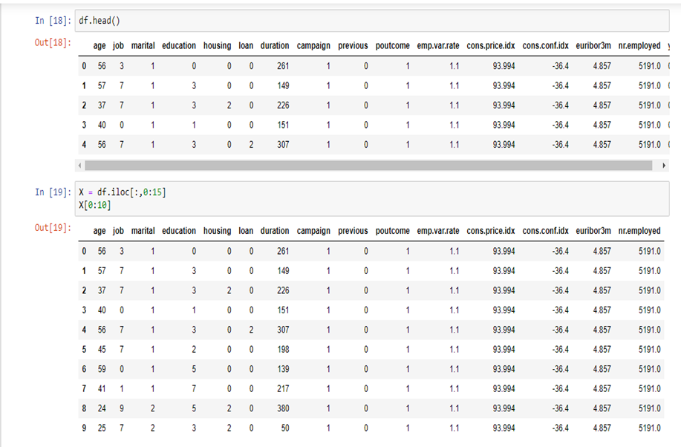

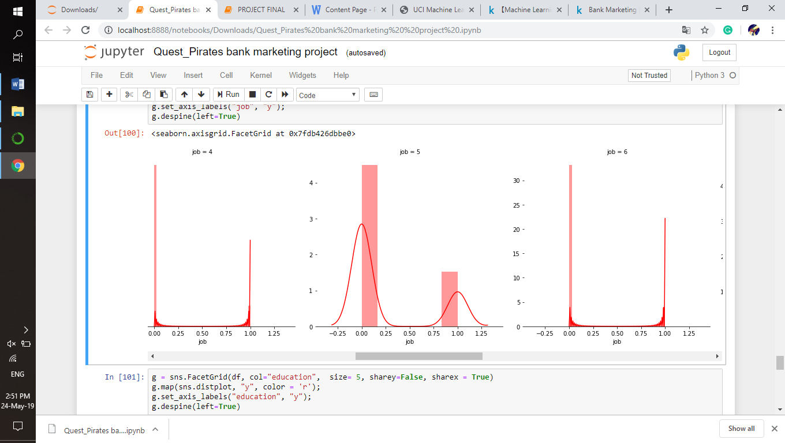

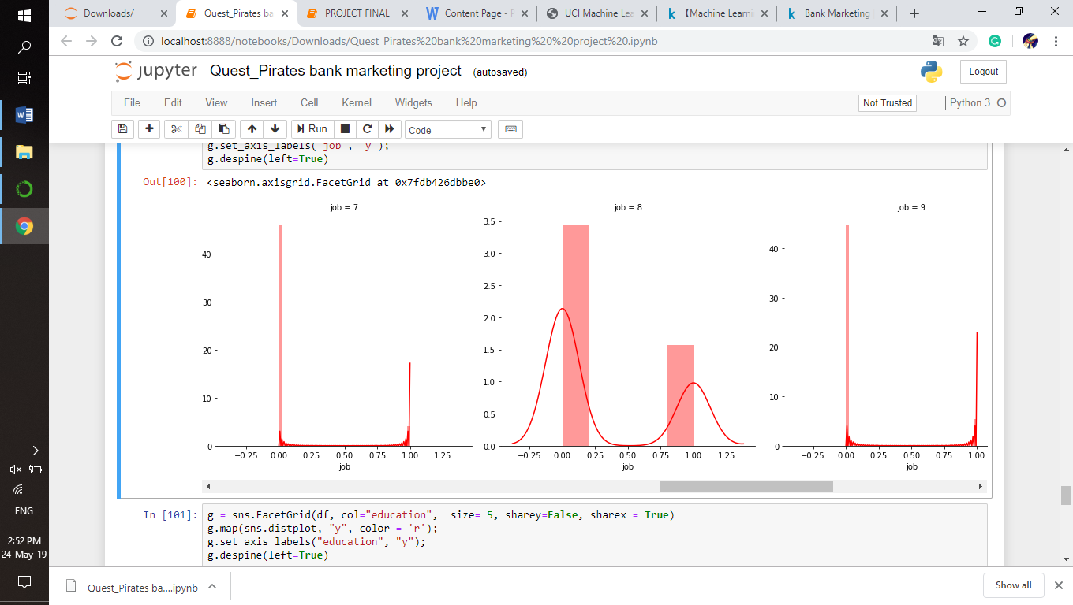

# 4.2 STATISTICAL TECHNIQUES AND DATA VISUALIZATION

# C:\Users\hp\OneDrive\Pictures\Screenshots\2019-05-24 (5).png

# C:\Users\hp\OneDrive\Pictures\Screenshots\2019-05-24 (6).png

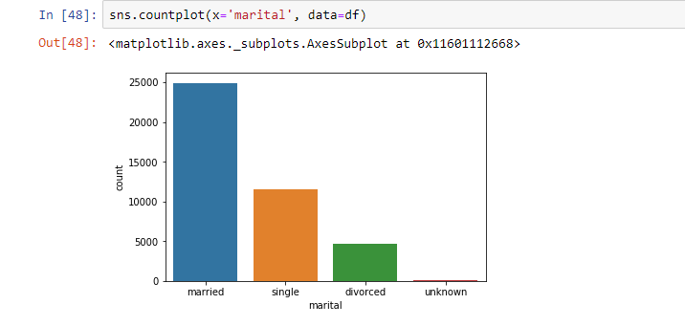

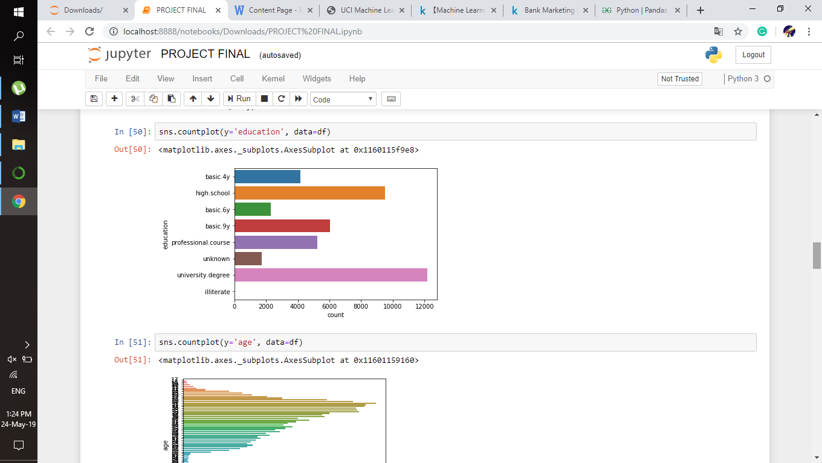

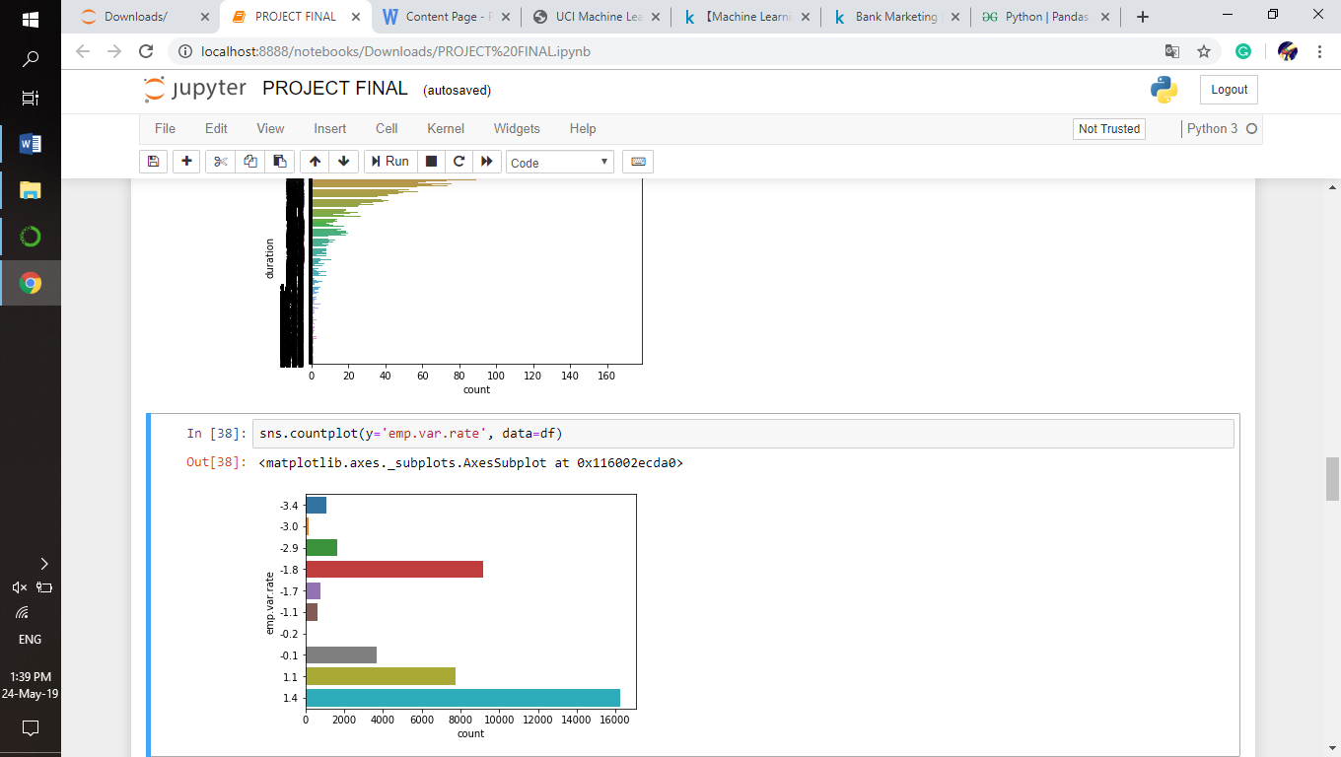

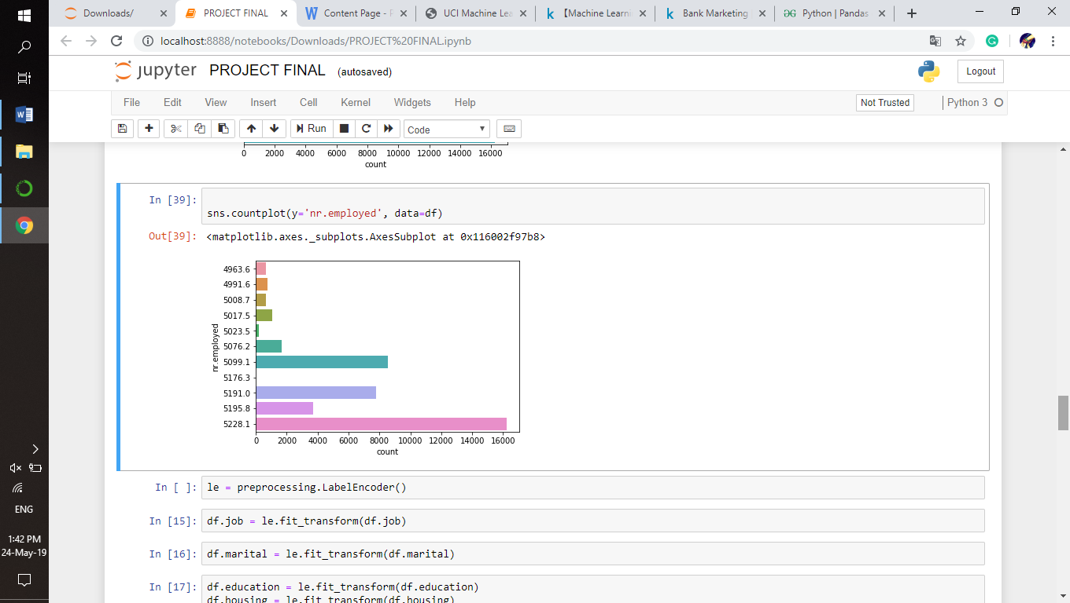

# 4.3 DATA MODELING USING SUPERVISED ML TECHNIQUES

[**Logistic regression**](http://www.statisticssolutions.com/academic-solutions/membership-resources/member-profile/data-analysis-plan-templates/data-analysis-plan-logistic-regression/) is the appropriate regression analysis to conduct when the dependent variable is dichotomous (binary).  Like all regression analyses, the logistic regression is a predictive analysis.  Logistic regression is used to describe data and to explain the relationship between one dependent binary variable and one or more nominal, ordinal, interval or ratio-level independent variables.

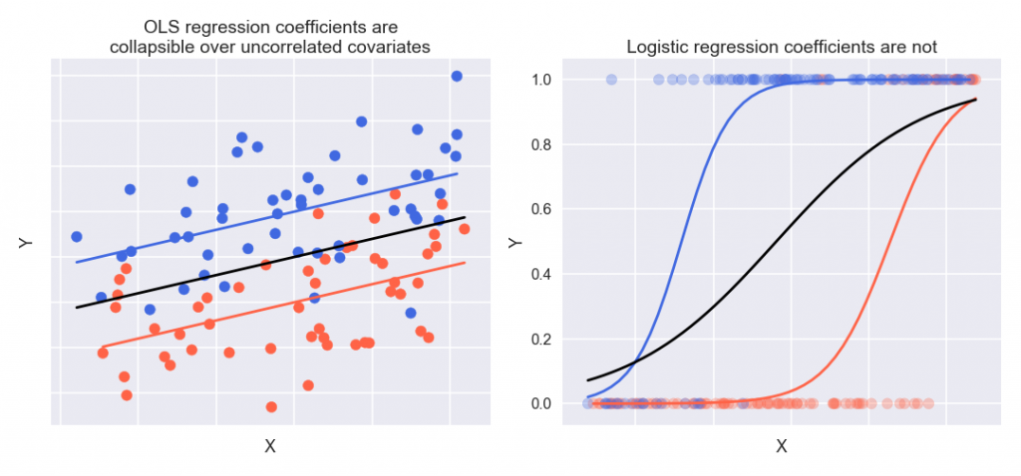

# 5 FINDING AND SUGGESTIONS

* Here duration attribute plays an important role in prediction. Duration attribute indicates the call duration between the customer and bank employee. The more the duration lasts, more likely the customer is interested in crediting (subscribing) for the deposit.
* From the count plots we can infer that the people who are married are more likely to subscribe for the deposit.
* And for the education attribute, the people with university degree holders are more likely to subscribe for the deposit.
* When implementing a marketing strategy, external factors, such as the time of calling, should also be carefully considered.

# 6 CONCLUSION

* Applying logistic regression algorithms, classification and estimation model were successfully built. With this model, the bank will be able to predict a customer's response to its telemarketing campaign before calling this customer.
* In this way, the bank can allocate more marketing efforts to the clients who are classified as highly likely to accept term deposits, and call less to those who are unlikely to make term deposits.
* Predicting the duration before calling and adjusting marketing plan benefit both the bank and its clients.

# 7 REFERENCE

* <https://www.kaggle.com/yufengsui/machine-learning-project-bank-marketing-analytics/notebook>
* <https://archive.ics.uci.edu/ml/datasets/bank+marketing>